**Information System Management Lab**

**BCOM 307**

**Assignment #16**

***Submitted by:***

**Name:** YASH JAIN

**Enrollment No:** 03914788818

**Semester:** B.Com(H) 5th Semester

**Class:** B.COM(H)

**Section:** B.Com 5A

**Date of Submission:** 11/10/2021

***Submitted to:***

**Praveen Kumar Singh**

**Assistant Professor, MAIMS**



**Department of Commerce**

**Maharaja Agrasen Institute of Management Studies**

**Affiliated to Guru Gobind Singh Indraprastha University, Delhi**

**Sector -22, Rohini, Delhi -110086, India; www.maims.ac.in**

Maharaja Agrasen Institute of Management Studies

Affiliated to GGS IP University; Recognized u/s 2(f) of UGC Recognized by Bar Council ofIndia; ISO 9001: 2015

Certified Institution Sector 22, Rohini, Delhi -110086, India; [www.maims.ac.in](http://www.maims.ac.in/)

Department of Commerce

Academic Year: 2020-21

Semester: Vth

# Assignment No. 16

# Unit No:

**Course/Subject Code:** BCOM 307 **Subject Title: Information System Management Lab**

# Issue Date Last Date of Submission:

**Instructions for Students:**

# All Questions are Compulsory.

1. The student should attach proper cover page for each assignment clearly mentioning the Assignment No.
2. Each assignment should be prepared by the student individually with proper explaination and screenshots.
3. A4 size ruled sheets should be used for the assignment.
4. Assignment pages should be serially numbered at the bottom of page.

***During online education mode, upload scanned copy of the complete assignment including cover page latest by due date.***

|  |  |  |
| --- | --- | --- |
| **Question No.** | **Question** | **CO No.** |
| 1 | Change the city of client 101 to Delhi. | **CO1, CO2, CO3, CO4** |
| 2 | Add values for designation column - Manager, Salesman, Admin. |
| 3 | Display the values of balance due and salary for clients 101 and 108. |
| 4 | Count the total number of clients. |
| 5 | Calculate the average salary of all clients. |
| 6 | List the names of clients living in a city starting with ‘D’. |
| 7 | display the total and average salary of all clients. |
| 8 | Change the city of salesman to Pune. |

**ASSIGNMENT 16 - AGGREGATE FUNCTIONS II**

**Task 1 : Change the city of client 101 to Delhi.**

This task can be completed using the **UPDATE Command**, along with the **SET** keyword, and the **where** clause.

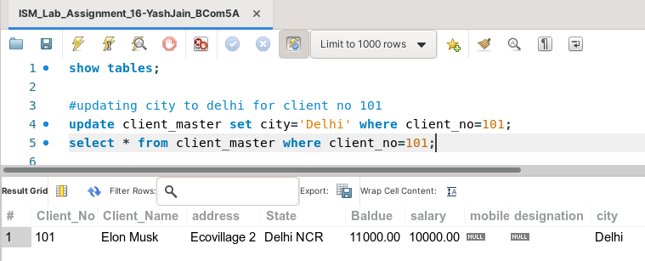

**Task 2: Add values for designation column - Manager, Salesman, Admin.**

This task can be completed using the **UPDATE Command**, along with the **SET** keyword, and the **where** clause.

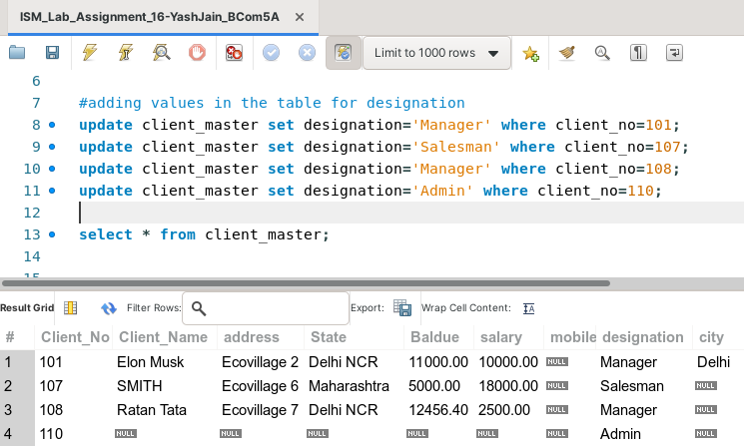

**Task 3: Display the values of balance due and salary for clients 101 and 108.**

This task can be completed using the **SELECT Command**, along with the **IN** keyword, and the **where** clause.

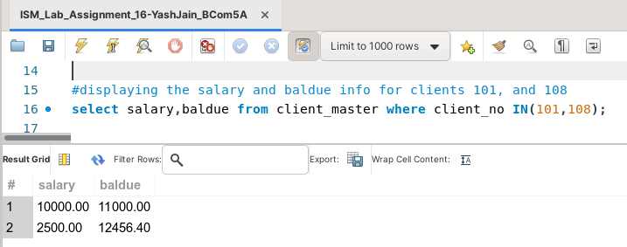

**Task 4: Count the total number of clients.**

This task can be completed using the **COUNT(*) aggregate function**.

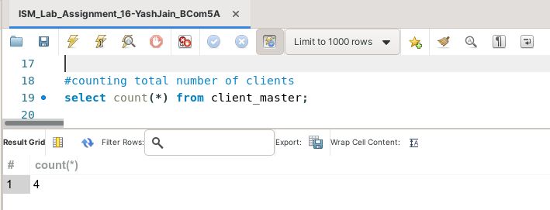

**Task 5: Calculate the average salary of all clients.**

This task can be completed using the **AVG() aggregate function**.

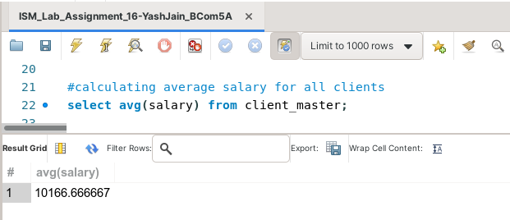

**Task 6: List the names of clients living in a city starting with ‘D’.**

This task can be completed using the **SELECT command**, along with the **where** clause and the **LIKE** operator.

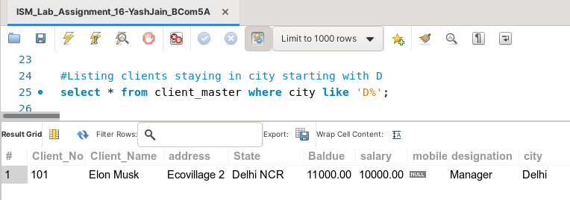

**Task 7: display the total and average salary of all clients.**

This task can be completed using the **aggregate functions SUM() and AVG()**.

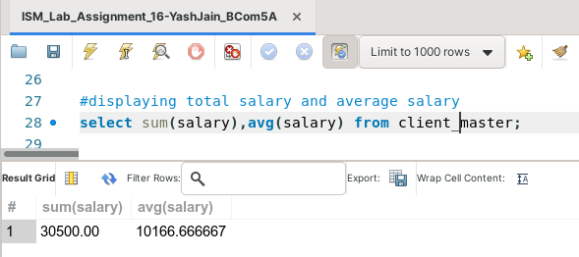

**Task 8: Change the city of salesman to Pune.**

This task can be completed using the **UPDATE Command**, along with the **SET** keyword, and the **where** clause.

